**MUSE:**

**Orientation + Location**

**Complementary Filter + Particle Filter**

1. IMU contains Accelerometer, Magnetometer, Gyroscope.
2. Traditional methods use Accelerometer as orientation anchor (or the core sensor for orientation), while Accelerometer can be erroneous while the device is moving (Actually accelerating is different than simply moving)
3. We propose MUSE. MUSE is a **Magnetometer-centered** sensor fusion method.
4. Transition from Local Reference Frame (LRF) to Global Reference Frame can be difficult. (In practice, not theoretically difficult, because the orientation is not clear)
5. $A^{3}$ is a good approach. $A^{3}$ opportunistically capture the moments that the device is static, to re-calibrate the orientation.
6. A3 is not good enough.

‘Unfortunately, objects may not pause often, and even if they do, determining those moments produces false positives and false negatives.’

‘We believe that A3 is an elegant contribution, however, the shortcoming is that such opportunities are infrequent.’

Figure 3 show the fluctuation of acceleration readings.

1. MUSE Orientation estimation workflow

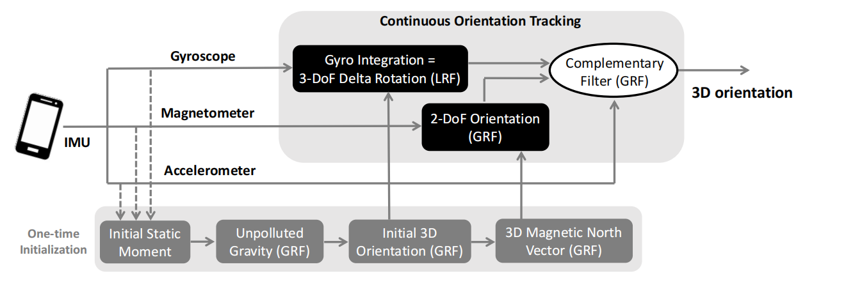

1. **MUSE initializes at a static state.**
2. **Complementary Filter** is good at fusing long-term-stable data and short-term-stable data. In this case, Magnet is stable in the long run, and Gyro is stable in short term.
3. Disparity elimination after Complementary Filter. **( 3.2 (3)-(5) )**
4. MUSE also opportunistically detects static or slow-moving opportunities in order to re-calibrate orientation **(Same as A3 [6] )**
5. ‘Unlike A3 which simply replaces current orientation estimation with the one from gravity + North, MUSE uses a complementary filter to update the estimation, which turns out to be more robust to accelerometer noise and have less false positives’. **(However this doesn’t explain that they face the same issue with A3 [6] )**

MUSE also fails if the device never stops moving(accelerating)

1. In conclusion, when the device is moving(accelerating), MUSE uses Magnet and Gyro for fusion via complementary filter. When the device is static, MUSE re-calibrates the orientation. (Algorithm1 pseudo code)
2. Ground truth is obtained by periodically bringing the device to a pre-specified orientation.
3. Experiments: pure translation, pure rotation, mixtures of translational and rotational motions.
4. Good orientation estimation performance (Of course)
5. MUSE Location estimation workflow:

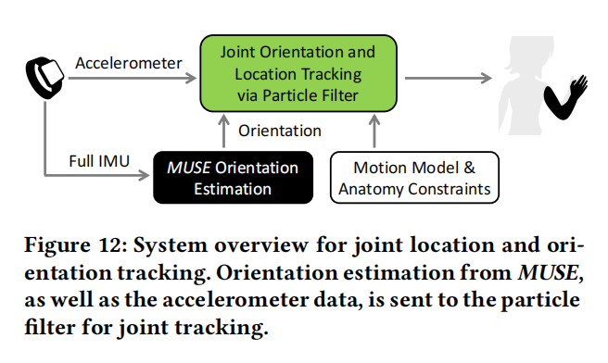

1. MUSE first estimates orientation, and then uses **particle filter** and domain knowledge to estimate wrist location.
2. No experiment performed across existing methods.
3. Orientation estimation can be performed on edge device, while location estimation can only be performed with PC or Cloud computing.